16 - Cure – Boys Don’t Cry
Original: A Us: same Undo previous transposition
KORG:PINCH, YAM:piano1

[Intro] Melody enters with drums
A | bm | c#m | D D c#m bm [4x]

[Verse]
A | bm | c#m | D [2x]
c#m | bm [4x] | 1st & 2nd verse only  3rd verse: skip to bridge  4th verse: skip to chorus
[Chorus]
Intro chords [2x] with the melody
[Bridge]
E | f#m7 [3x]
D | E Go to Verse (no melody)
[Outro] is Chorus [melody every time]
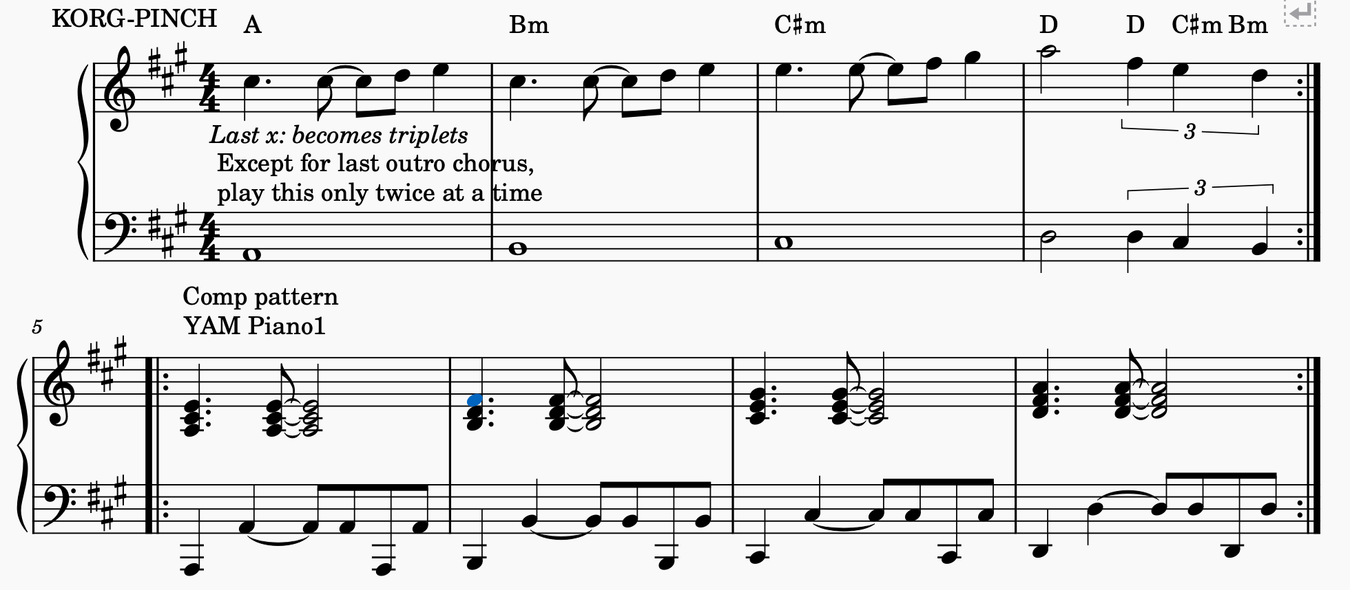
LAST time ‘break’ the chords

